Integrated Smart Home Automation & Security
Simulation System
Abstract
The Smart Home Automation & Security Simulation System is an IoT-based embedded project that integrates multiple sensors and actuators to simulate modern residential automation. The system monitors environmental conditions such as temperature, humidity, light intensity, and motion, and takes real-time decisions using an ESP32 microcontroller. It also includes a dual-mode security system (Normal and Security mode) and uploads sensor data to the ThingSpeak cloud platform for remote monitoring and analysis.
Objective
- To design a smart home system using ESP32
- To automate lighting and climate control based on sensor data
- To implement a security system using PIR motion sensor
- To simulate smart door control using servo motor
- To integrate IoT cloud monitoring using ThingSpeak
- To implement mode-based system control (Normal / Security)

System Overview
The system consists of:
- ESP32 microcontroller (main controller)
- DHT22 temperature and humidity sensor
- LDR (light sensor)
- PIR motion sensor
- Servo motor (door control)
- Buzzer (alarm system)
- LEDs (indicators and control)
- Push buttons (door + mode control)
- ThingSpeak IoT cloud platform
Working Principle
The system continuously reads data from sensors and performs actions:
Smart Lighting Module
- LDR measures ambient light
- LED turns ON in low light conditions
Climate Control Module
- DHT22 measures temperature
- Cooling LED turns ON if temperature exceeds threshold (30°C)

Security System
- PIR detects motion
- In Normal mode → simple alarm
- In Security mode → fast alert buzzer
Door Control System
- Push button activates servo motor
- Door opens (90°) and closes after delay
Mode Control System
- Button toggles between:
  - NORMAL mode
  - SECURITY mode
IoT Cloud Integration
- Data sent to ThingSpeak:
  - Temperature
  - Humidity
  - Light
  - Motion

Modules Description
Adaptive Climate Control Module
Monitors temperature using DHT22 and activates cooling LED when temperature exceeds threshold.
Intelligent Ambient Illumination Module
Uses LDR sensor to control LED based on ambient light conditions.
Intrusion Detection System
PIR sensor detects motion and triggers buzzer alarm based on system mode.
Automated Door Control System
Servo motor simulates door operation controlled via push button.
Mode Control System
Switches system between Normal and Security modes.
IoT Cloud Module
Uploads real-time sensor data to ThingSpeak for remote monitoring.

Hardware Components
- ESP32 Development Board
- DHT22 Sensor
- LDR Sensor
- PIR Sensor
- Servo Motor
- Buzzer
- LEDs
- Push Buttons
- Resistors
- Breadboard & Jumper wires
Software Used
- Arduino IDE / Wokwi Simulator
- ThingSpeak IoT Cloud Platform
- ESP32 Board Library
- DHT Sensor Library
- ESP32 Servo Library

Circuit Diagram
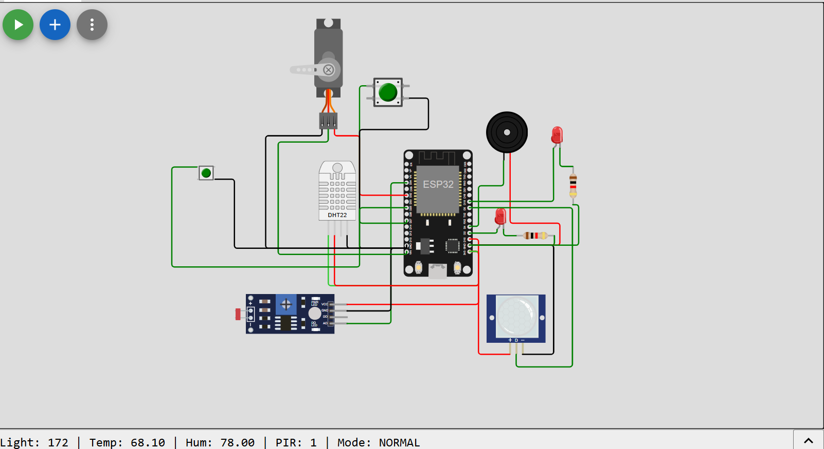
Algorithm
- Start system
- Initialize sensors and WiFi
- Read sensor values
- Check mode (Normal / Security)
- Control LED, buzzer, servo based on logic
- Send data to ThingSpeak
- Repeat every 15 seconds

Serial Monitor output
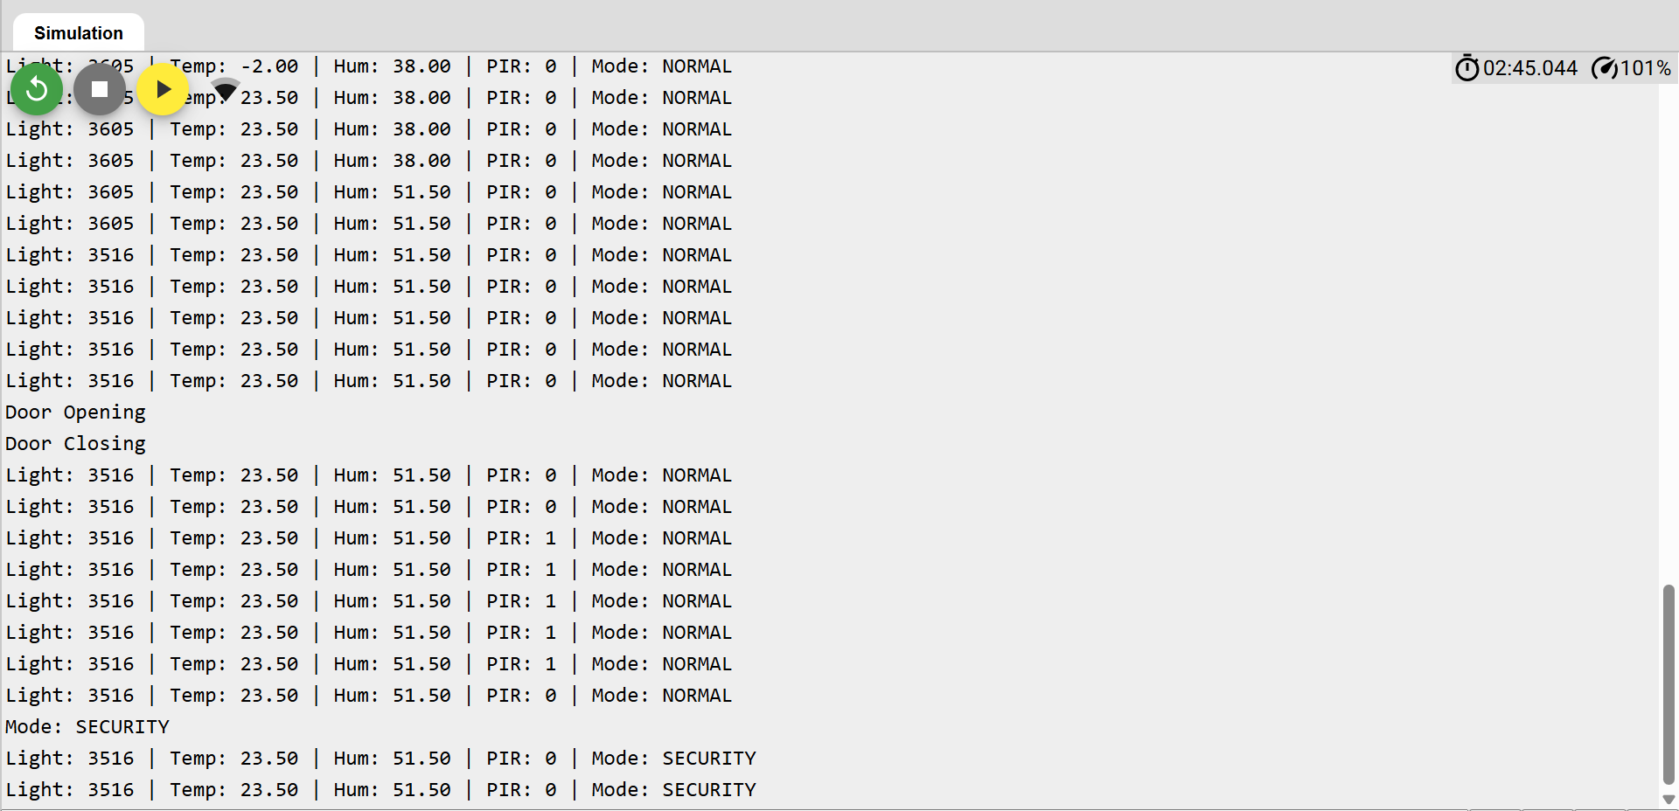

ThingSpeak Integration
Data fields:
- Field 1 → Temperature
- Field 2 → Humidity
- Field 3 → Light intensity
- Field 4 → Motion detection
Data is updated every 15 seconds using API key.
ThingSpeak waveforms
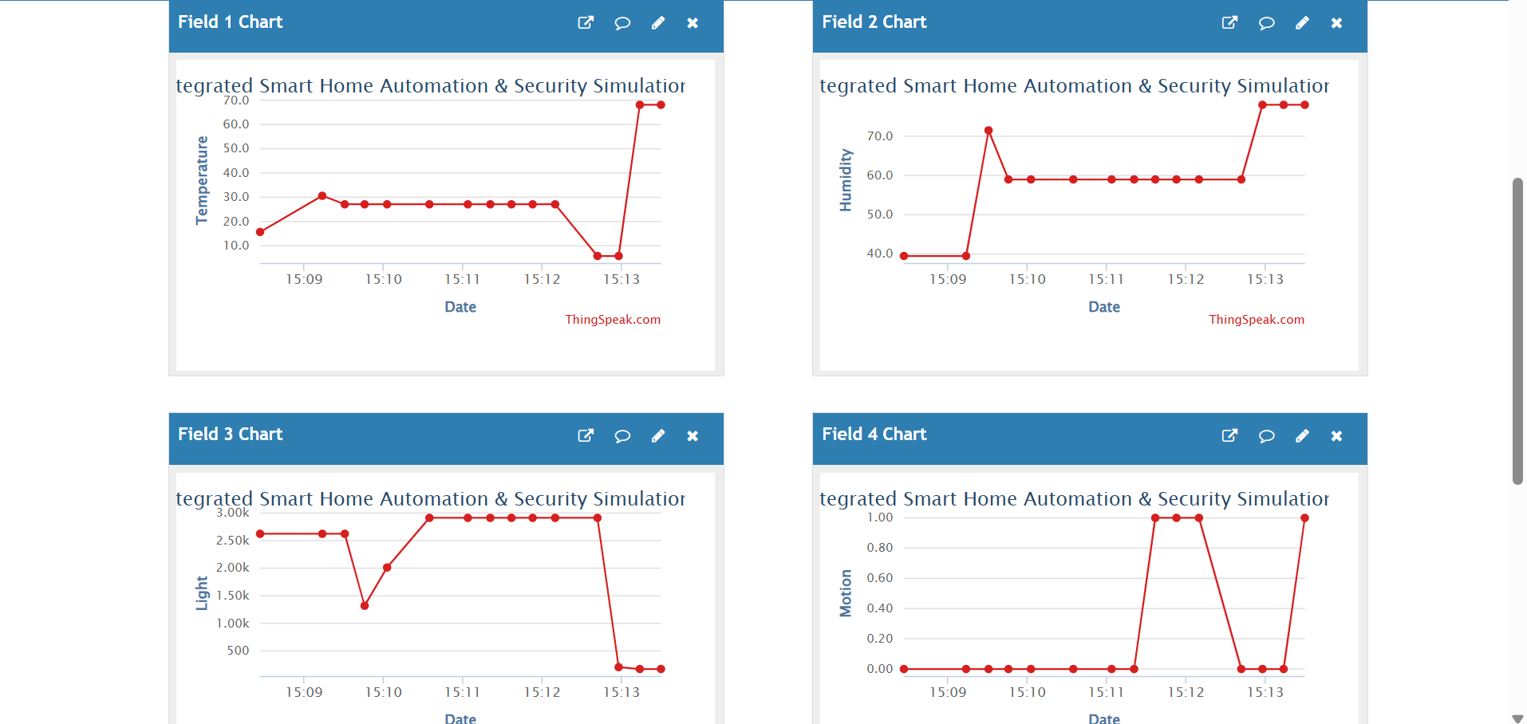
Applications
- Smart homes
- Home security systems
- Energy-efficient automation
- IoT-based monitoring systems
- Smart door systems
Advantages
- Real-time monitoring
- Energy efficient
- Cloud-based access
- Scalable system
Limitations
- Requires stable internet for IoT
- Simulation may differ from real hardware
- Limited actuator capacity
Conclusion
The Smart Home Automation & Security System successfully demonstrates an IoT-based embedded solution using ESP32. It integrates environmental monitoring, automation, security, and cloud communication into a single system. The project effectively simulates real-world smart home behaviour and provides a foundation for advanced IoT applications.

